Title of the Abstract

Author 1, Author 2, …, Author n

Affiliation 1, Address 1

Affiliation 2, Address 2

…

Affiliation n, Address n

Corresponding author telephone: (+xx) xxx-xxxxxxxx email: [xxx.xxx@xxx.xx](mailto:xxx.xxx@xxx.xx)

**Introduction.** This template is divided in sections. It is not mandatory to include specific sections, and the existing ones can either be deleted or renamed according to your needs. However, it is necessary to provide the introduction section at the beginning of the document and the conclusions section at the end of the main text. Please use the provided font size (Times 11) for the main text and use bold for the sections headings.

**Section I.** Include citations in the text in the following format [1]. Use consecutive numbers to cite references in the main text [2]. The total word count should not exceed 1000.

**Section III.** If you have to include equations, please use the word equation editor and include the item in the left column of a table with a single row. Use the right column to provide an ordinal number for the equation to be used in the main text as a reference. Here follows an example:

|  |  |
| --- | --- |
| $$F=ma$$ | (1) |

Please remove the borders form the table (here they are included for clarity). An equation could be referred to in the main text as follows. In eqn. (1), *F* is the force, *m* is the mass, *a* is the acceleration. Please specify any acronym the first time they appear and then use the acronym throughout the main text.

**Conclusions.** Please include here the main conclusions of your work.

**Acknowledgments.** Please include here possible acknowledgments. Please include all necessary references in the appropriate section at the end of the main text, as follows.

**References**.

1. A. B. et al., Nat. Comm., vol. XX, n. Y, p. ZZZ, Apr. 2021.
2. A. B. et al., Nat. Comm., vol. XX, n. Y, p. ZZZ, Apr. 2021.
3. A. B. et al., Nat. Comm., vol. XX, n. Y, p. ZZZ, Apr. 2021.
4. A. B. et al., Nat. Comm., vol. XX, n. Y, p. ZZZ, Apr. 2021.
5. A. B. et al., Nat. Comm., vol. XX, n. Y, p. ZZZ, Apr. 2021.
6. A. B. et al., Nat. Comm., vol. XX, n. Y, p. ZZZ, Apr. 2021.

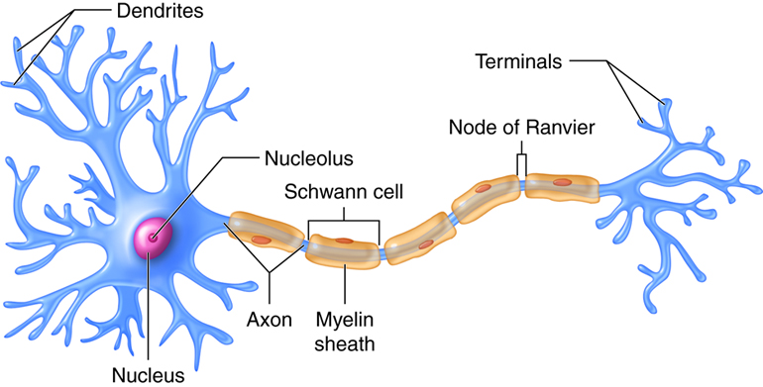

**Figure 1.** Include here the caption of the first figure. Use high quality figure files and center the item in the page. Leave a blank line before and after the caption as in this example.

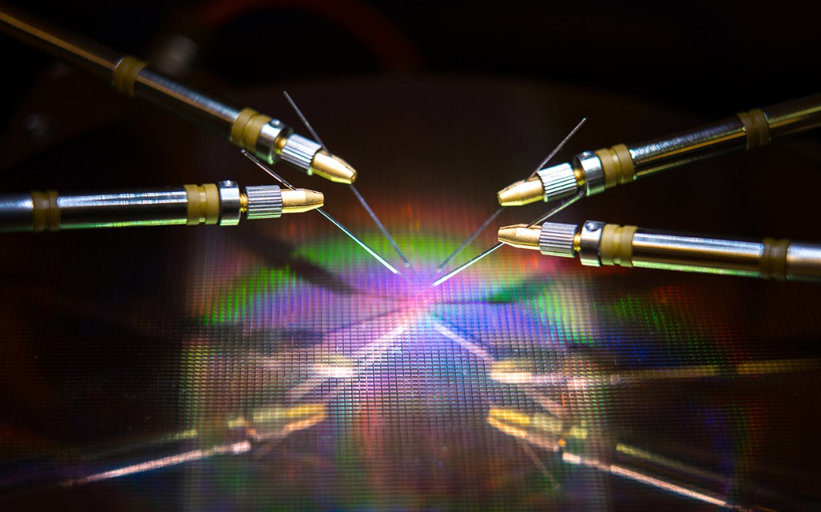

**Figure 2.** Include here the caption of the second figure. Use high quality figure files and center the item in the page. Leave a blank line before and after the caption as in this example.